MAWLANA BHASHANI SCIENCE AND TECHNOLOGY UNIVERSITY
SANTOSH, TANGAIL-1902



DEPARTMENT OF INFORMATION AND COMMUNICATION TECHNOLOGY
Lab Report

Lab Report No : 04
Lab Report on : Study of different realization structures of digital filters using MATLAB.
Course Title : Digital Signal Processing Lab
Course Code : ICT-3206

Submitted By | Submitted To
Name: Kuldip Saha Mugdha  ID: IT-22018  3rd Year, 2nd Semester  Session: 2021-2022  Dept. of ICT, MBSTU | Dr. Mst. Nargis Akter  Professor  DEPARTMENT OF INFORMATION AND COMMUNICATION TECHNOLOGY  MAWLANA BHASHANI SCIENCE AND TECHNOLOGY UNIVERSITY

Date of Performance: 23/11/25 Date of Submission: 01/12/25
Introduction:
Digital filters are widely used in signal processing to modify or enhance signals. These filters can be implemented in different realization forms such as direct, parallel, and cascade structures. Each realization has its own advantages in terms of stability, complexity, and numerical accuracy. This experiment demonstrates parallel and cascade form realizations of FIR and IIR digital filters using MATLAB.

Objective:
- To realize an IIR filter in parallel form.
- To convert a direct form filter into cascade form.
- To implement FIR and IIR filters using cascade realization.

Theory:
- Parallel form realization represents a filter as a sum of first- or second-order subsystems using partial fraction expansion.
- Cascade form realization represents a filter as a product of second-order sections obtained from the roots of numerator and denominator polynomials.
- Cascade and parallel forms are preferred over direct form for better numerical stability.

MATLAB Code :
Program 1: Parallel Form Realization of IIR Filter
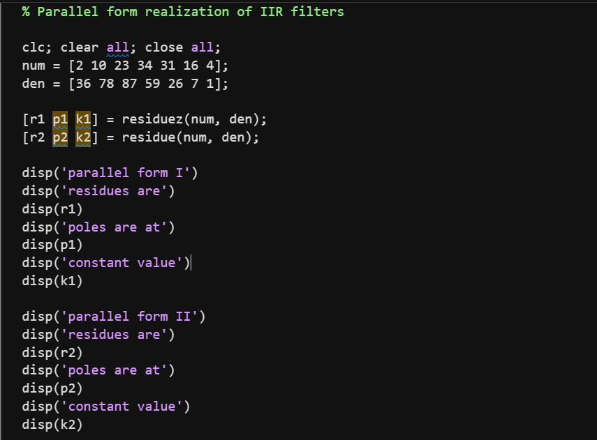

Output:
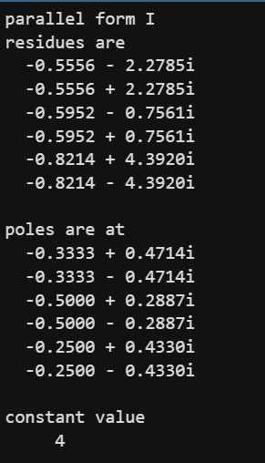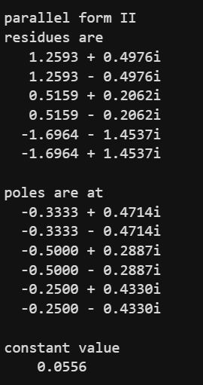
Program 2: Direct Form to Cascade Form Conversion
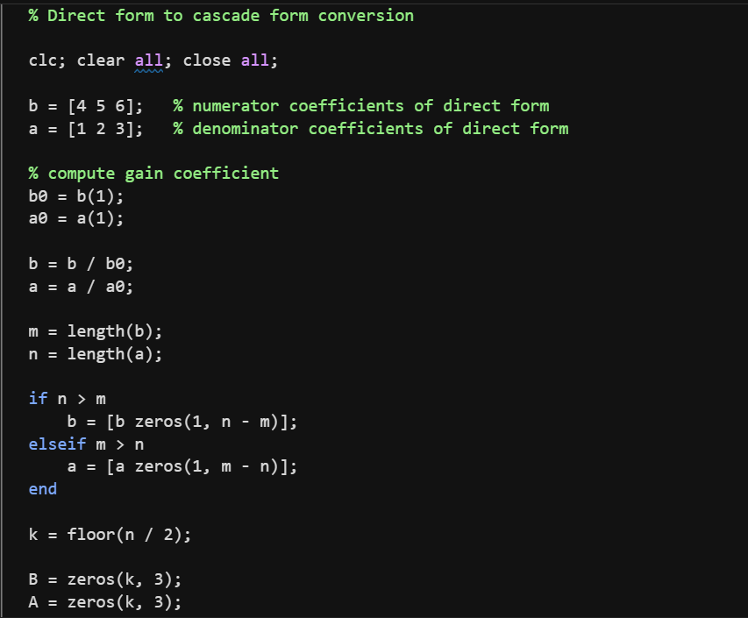
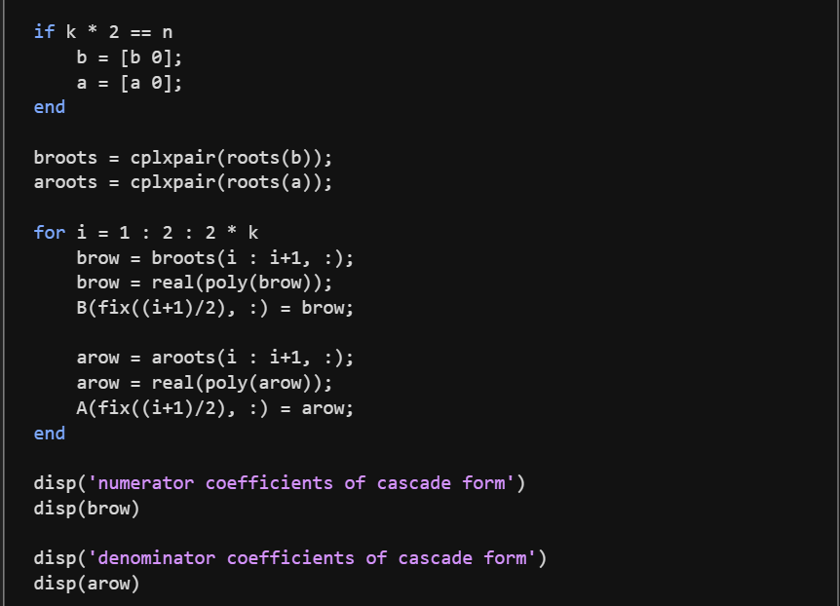

Output:
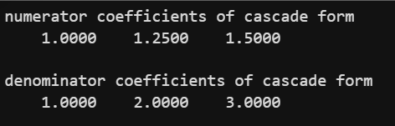
Program 3: Cascade Form Realization of FIR & IIR Filters
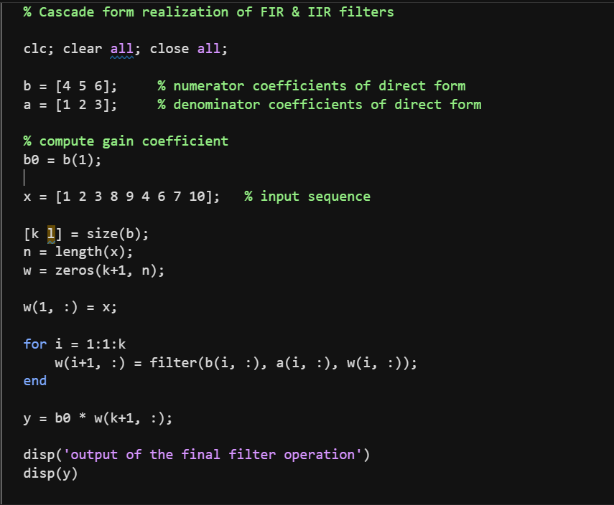
Output:

Result:
- Parallel form realization of the IIR filter was obtained successfully.
- Direct form filter was converted into cascade form correctly.
- FIR and IIR filters were implemented using cascade structure and the output was observed.

Conclusion:
This experiment demonstrated different realization structures of digital filters including parallel and cascade forms. These structures improve numerical stability and are commonly used in practical DSP applications.

